**Write a Python Program to Remove punctuations from the given String**

**Program:**

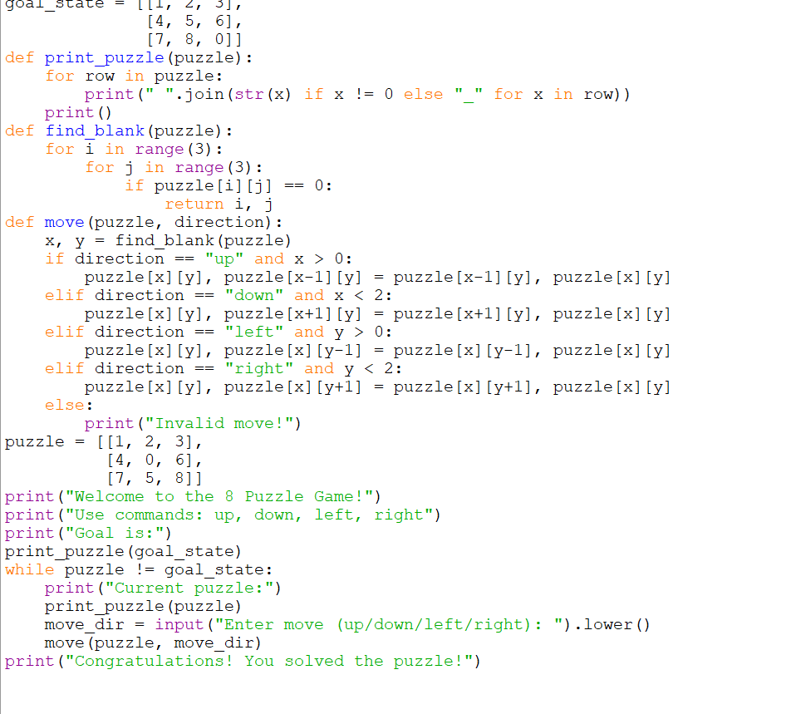

**Output:**

